Technical Analysis

The Chart Formation, We use the currency pair of Eur/Usd for illustration ,

The Evening star pattern(a three candlestick pattern) as shown below,the shooting star form as the top of the star(second candlestick) and follow by the fall of the third candlestick.

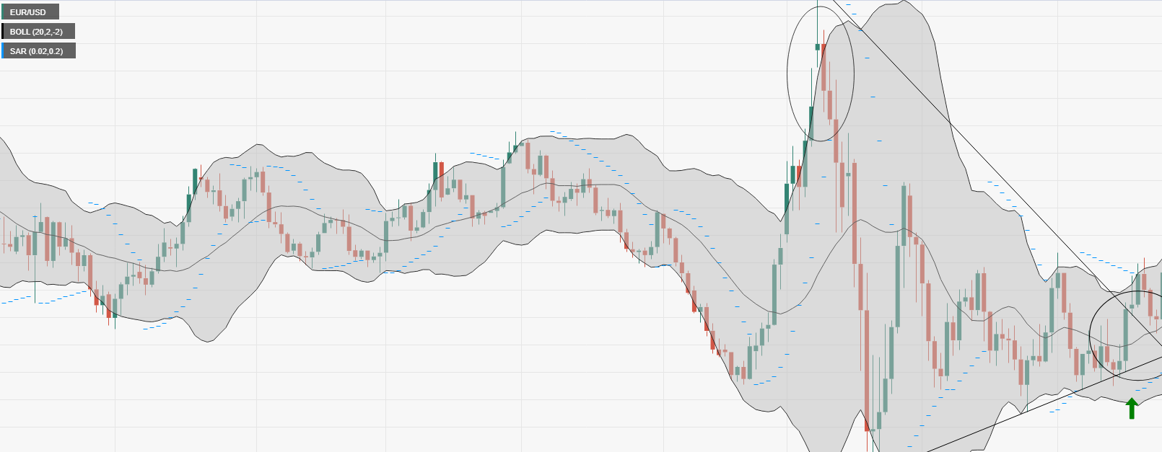

The symmetrical triangle pattern as shown below,the lower hi and the higher low forming toward a meeting point and deciding on which direction.

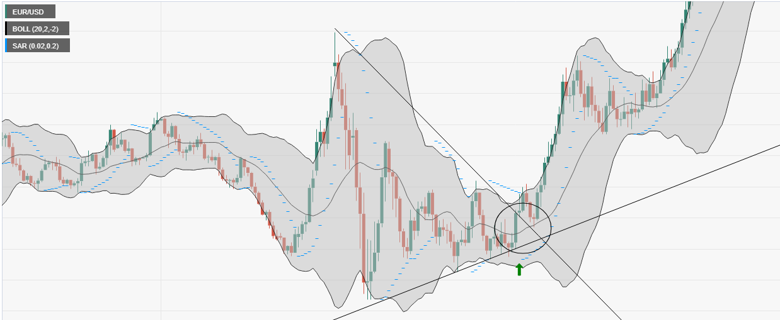

Tweezer (BULL) ,the next candle is of about the same body with a reversal directional. For theis case,

It is a bull candle followed by a bear candle.

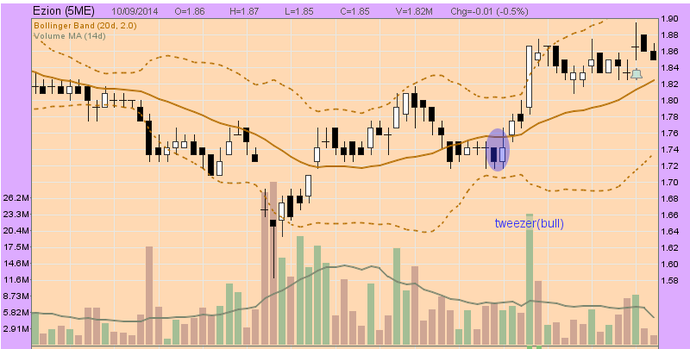

Tweezer (Bear) the next candle is of about the same body with a reversal directional.For theis case,

It is a bull candle followed by a bear candle.

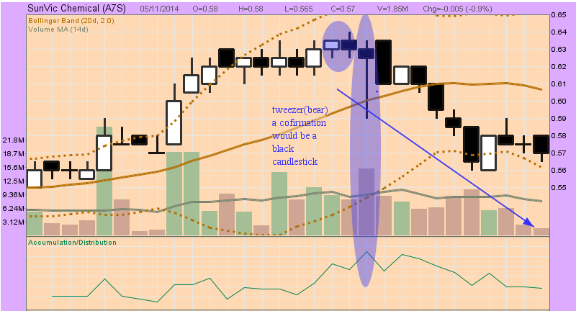

Special Advance Block with shooting star formation that lead to a probability for a downward price action

